Lab Assignment 6

(KNN Algorithm)

**Name:** Sourabh Barala

**Course:** M.Sc. Data Science

**Year:** 1st

**Reg. No.:** 23MSD7044

**Subject:** Machine Learning and its Applications

**Implementation:**

**cal_dist:**

This funtion calculates distance of a data point with all data points

**input:**

point: one data point

train_para: all other data points

train_label: labels of ecach data points in train_para (1- dimensional)

**output:**

DataFrame with distances from a given point to all points, with labels

**example:**

temp_cls.cal_dist(point=X_train.iloc[0],

train_para=X_train,

train_label= y_train.values.ravel())

output:

dist class

0 0.000000 1

1 38.449169 1

2 271.548671 1

3 109.262951 1

4 160.529340 1

... ... ...

421 1252.334390 0

422 574.286256 0

423 1519.622517 0

424 1552.695208 0

425 184.725959 1

**get_closest_class:**

This function takes DataFrame given by cal_dist function ,sorts the DataFrame according to diatance then selects top 'k' smallest distances and returns label with max count.

**input:**

dist_df: DataFrame given by cal_dist function

**output:**

label with max count

**example:**

temp=temp_cls.cal_dist(point=X_train.iloc[0],

train_para=X_train,

train_label=y_train.values.ravel())

temp_cls.get_closest_k_classes(temp)

output:

1

**predict**

This function predicts class of each point and appends in a list

**input:**

test_para: points to be classified

**output:**

list with predicted classes for each point

**example:**

temp_cls.fit(X_train,y_train.values.ravel())

pred=temp_cls.predict(X_test)

pred=np.array(pred)

output:

array([1, 0, 1, 1, 0, 1, 0, 1, 1, 1, 1, 1, 1, 1, ....])

**Elbow Method**

accuracy_score, f1_score, precision_score, recall_score are calculated with value of K in range 1 to 14.

Observation:

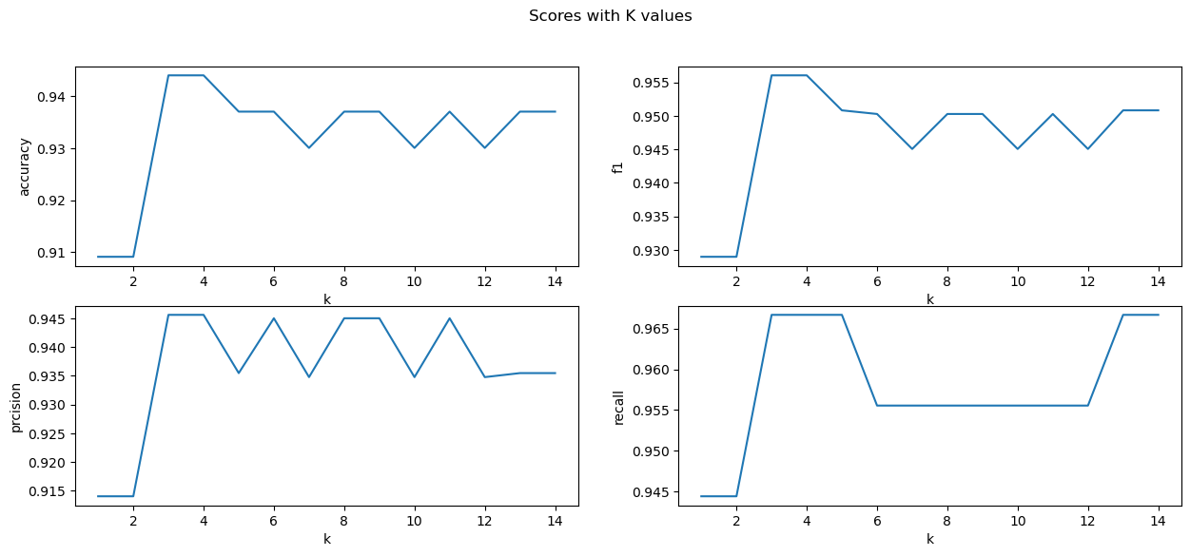

K=3,4,5 gives best scores